EX No:1b | EDA DATA CLEANING

AIM

To perform Exploratory Data Analysis and Data Cleaning on the California Housing Dataset by examining the dataset structure, dimensions, data types, statistical characteristics, missing values, duplicate records, housing-value distributions, ocean-proximity-wise housing patterns, housing-feature-wise statistics, correlation between numerical attributes, top housing records based on house value and income, and exporting the cleaned dataset for further analysis.

ALGORITHM
- Import the required libraries such as Pandas and NumPy.
- Load the California Housing Dataset into a Pandas DataFrame.
- Display the first five and last five records of the dataset.
- Display the dataset information, shape, column names, and data types.
- Generate descriptive statistical information for numerical attributes.
- Identify the missing values present in each column.
- Remove completely blank rows and duplicate records from the dataset.
- Standardize the ocean proximity categorical attribute by removing unwanted spaces and converting values to uppercase.
- Convert numerical attributes into appropriate numeric data types and handle missing numerical values using median imputation.
- Analyze the statistical characteristics of median house values.
- Analyze the distribution of house values across different ocean proximity categories.
- Analyze important housing features such as total rooms, total bedrooms, population, households, median income, and median house value.
- Calculate the correlation between numerical attributes in the dataset.
- Identify the top 10 housing records based on median house value.
- Identify the top 10 records based on median income.
- Export the cleaned dataset into CSV, Excel, and JSON formats.
- Display a confirmation message after successful creation of the cleaned dataset files.

CODE
import pandas as pd
import numpy as np

# Load dataset
path = "/content/housing prices.csv"
df = pd.read_csv(path)

print("\nFirst 5 rows:")
display(df.head())

print("\nLast 5 rows:")
display(df.tail())

print("\nDataset information:")
df.info()

print("\nShape:")
print(df.shape)

print("\nColumns:")
print(df.columns.tolist())

print("\nData types:")
print(df.dtypes)

print("\nStatistical description:")
display(df.describe())

print("\nMissing values:")
display(df.isnull().sum())

# Data cleaning
df = df.dropna(how="all")
df = df.drop_duplicates()

df["ocean_proximity"] = (
df["ocean_proximity"].astype(str).str.strip().str.upper()
)

numeric_columns = df.select_dtypes(include=np.number).columns

for col in numeric_columns:
df[col] = pd.to_numeric(df[col], errors="coerce")
df[col] = df[col].fillna(df[col].median())

print("\nMissing values after cleaning:")
display(df.isnull().sum())

print("\nCleaned dataset shape:")
print(df.shape)

# Housing value analysis
print("\nHousing Value Statistics:")
display(
df["median_house_value"].agg(
["count", "mean", "median", "std", "min", "max"]
)
)

# Ocean proximity analysis
print("\nOcean-Proximity-wise Housing Analysis:")
display(
df.groupby("ocean_proximity")["median_house_value"]
.agg(["count", "mean"])
.sort_values("mean", ascending=False)
)

# Feature-wise analysis
print("\nHousing Feature-wise Statistics:")
display(
df[
[
"total_rooms",
"total_bedrooms",
"population",
"households",
"median_income",
"median_house_value"
]
].describe()
)

# Correlation
print("\nCorrelation:")
display(df.corr(numeric_only=True))

# Top 10 houses
print("\nTop 10 Houses by Median House Value:")
display(
df.sort_values("median_house_value", ascending=False)
.head(10)[
[
"longitude",
"latitude",
"median_income",
"total_rooms",
"median_house_value",
"ocean_proximity"
]
]
)

# Top 10 by income
print("\nTop 10 Records by Median Income:")
display(
df.sort_values("median_income", ascending=False)
.head(10)[
[
"longitude",
"latitude",
"median_income",
"median_house_value",
"ocean_proximity"
]
]
)

# Export cleaned dataset
df.to_csv("housing_prices_cleaned.csv", index=False)
df.to_excel("housing_prices_cleaned.xlsx", index=False)
df.to_json("housing_prices_cleaned.json", orient="records", indent=4)

print("\nCSV, Excel and JSON files created successfully.")

OUTPUT

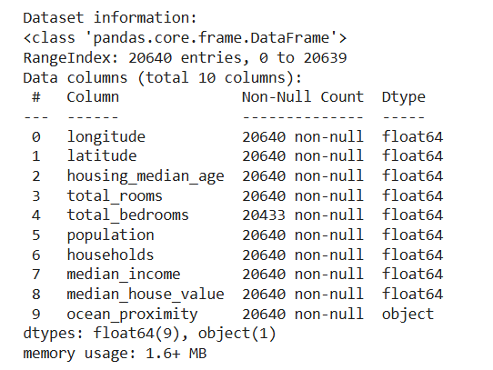

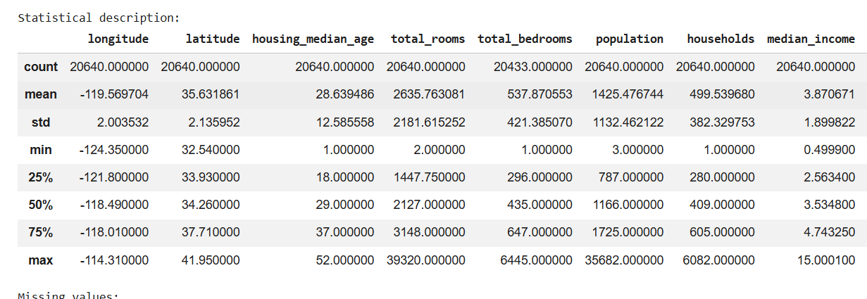

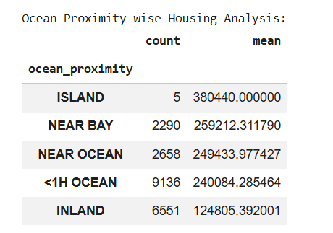

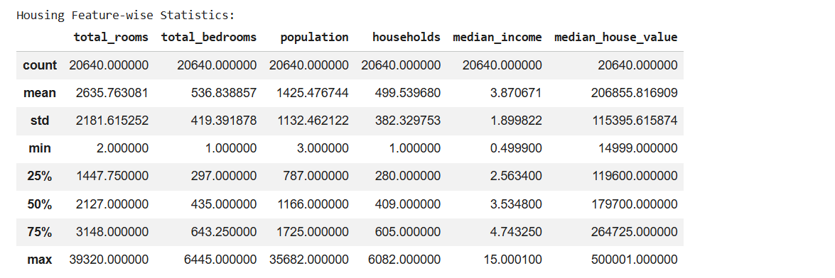

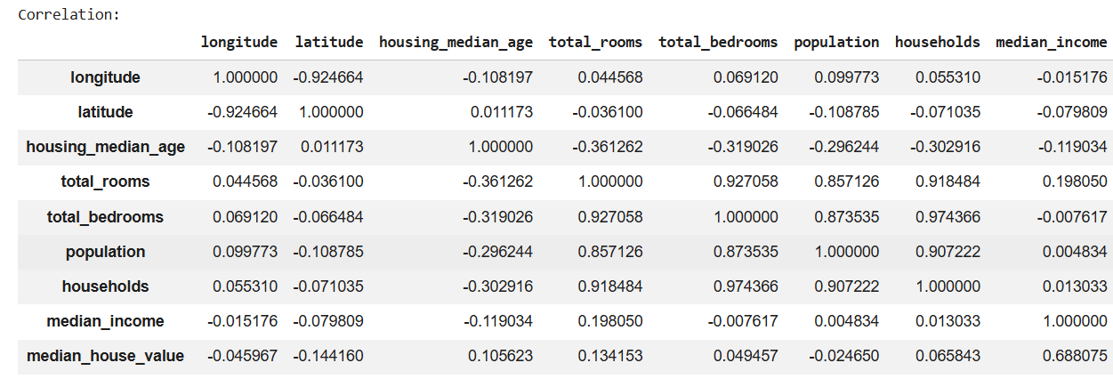

RESULT

